Assignment 5.2/6.2
Robert Breutzmann's CSD430 GitHub
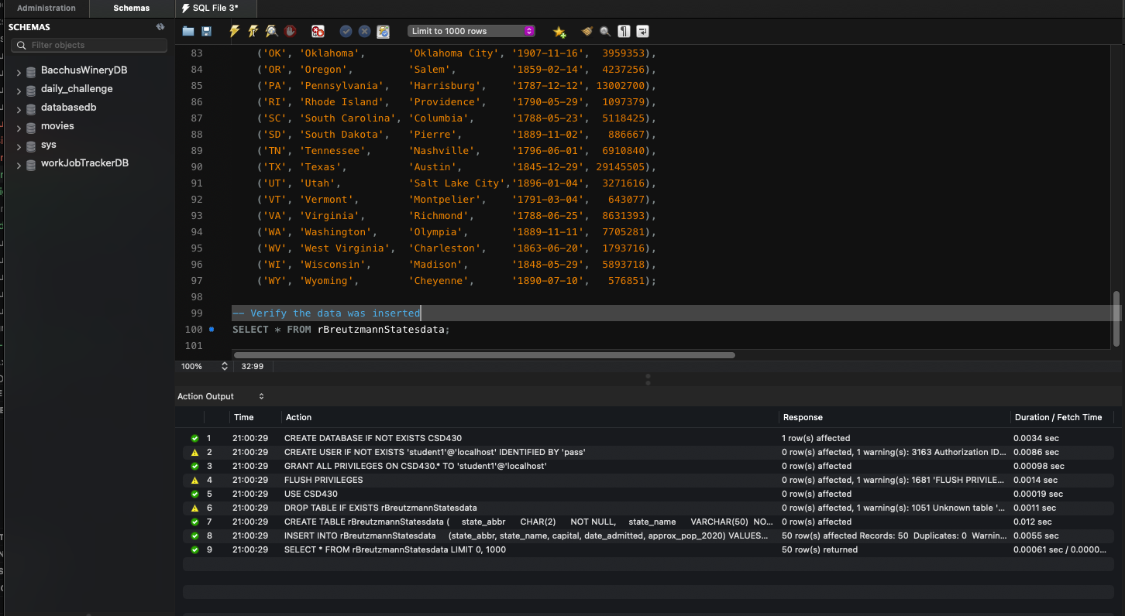

Database Created Log (MySQL Workbench)

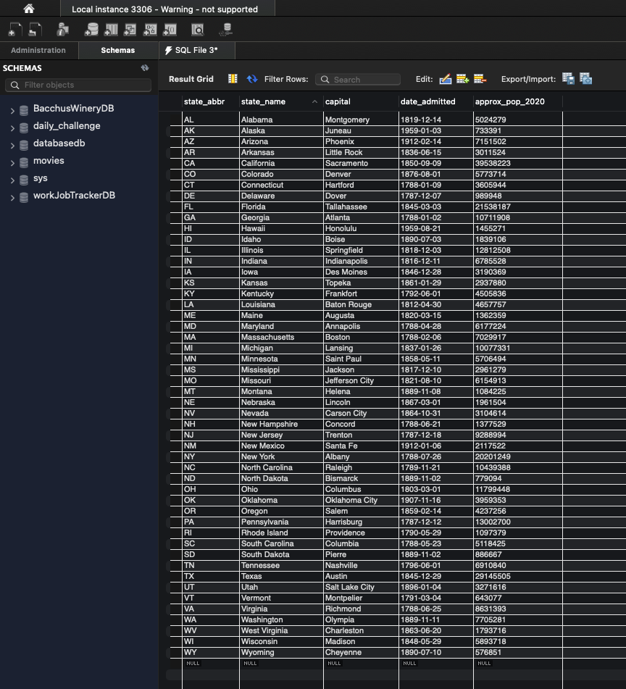

Result from Query
SELECT * FROM rBreutzmannStatesdata

